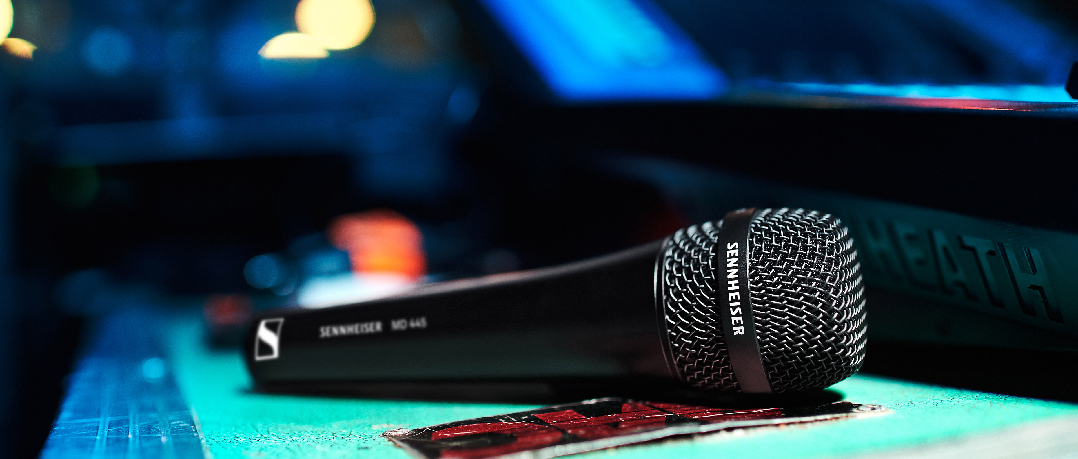

New Sennheiser MD 445 vocal mic
Get maximum presence and feedback rejection

Marlow, UK, November 18, 2020 – The stage is incredibly loud, with the instruments seeming to acoustically close in on the vocalist… – these are challenging environments for which the new MD 445 from Sennheiser was created. The audio specialist’s large-diaphragm, dynamic stage microphone combines a direct, head-on sound with a tight super-cardioid pick pattern, providing not only maximum isolation from other on-stage sound sources but also an extremely high level of feedback resistance. With the high-rejection MD 445, vocalists can effortlessly assert their presence even in the loudest of environments.

“The MD 445 is the most powerful microphone in our MD range,” says Kai Lange, senior product manager with Sennheiser. “If its sister model, the MD 435, is the beauty, the MD 445 certainly is the beast. It effortlessly cuts through loud stage sound and establishes an audibly greater proximity to the vocals. Its direct, high-resolution sound gives vocals a totally new richness, intensity and assertiveness.”

The acoustics of the MD 445 have been tailored to modern stage set-ups with B stages and runways in front of the PA. At the core of the acoustic design is a newly developed voice coil made of lightweight aluminium-copper. Its fast transient response ensures a very detailed, nuanced and transparent sound that is complemented by rich mid-range and bass. The sound is acoustically close, intimate and open, irrespective of how loud the instrument soundscape may be.

Thanks to its high-rejection, super-cardioid pick-up pattern, the MD 445 has enormous gain before feedback. Dynamics are wide at 146 dB(A) and the microphone can handle sound pressure levels of up to 163 dB/1 kHz.

The outstanding acoustics come with a mechanical design that’s built to withstand a life on tour: The MD 445 features a metal casing and has a shock-mounted capsule to protect it from structure-borne noise. A hum compensating coil protects the microphone against electromagnetic interference.

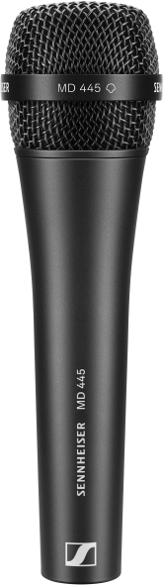 | 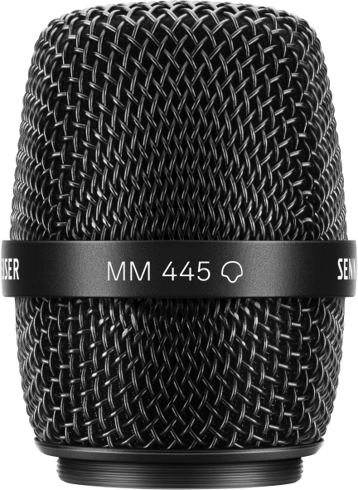  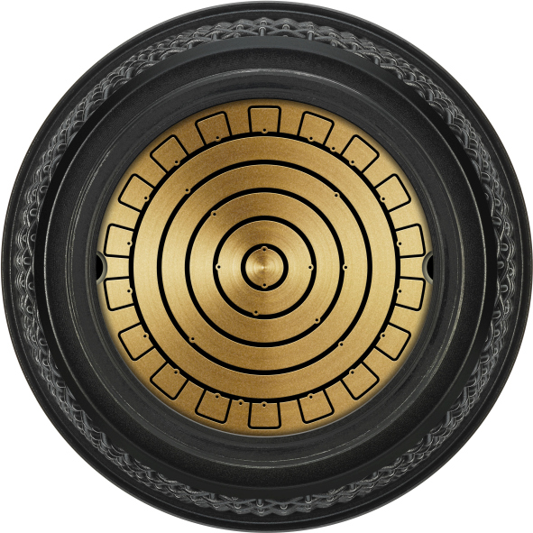 | The wired, super-cardioid MD 445 vocal microphone and the MM 445 microphone head (pictured with the capsule interface) for use with Sennheiser wireless transmitters

For use with Sennheiser’s wireless transmitters, the capsule of the MD 445 is also available as MM 445 microphone head. Fitted with Sennheiser’s standard capsule interface, the MM 445 can be used with Sennheiser wireless series ranging from the evolution wireless G4 and 2000 series to Digital 6000 and Digital 9000.

The MM 445 microphone head combined with an SKM 6000 handheld transmitter

The MD 445 microphone and MM 445 microphone head retail at 499 (MSRP) each.

MD 445 Technical Data
Transducer principle dynamic
Frequency response 40 – 20,000 Hz
Pick-up pattern high-rejection, super-cardioid
Sensitivity (free field, at 1 kHz) 1.6 mV/Pa; -55.9 dBV/Pa
Max. SPL (at 1 kHz) 163 dB
Equivalent noise level 18 dB(A)
Dynamic range 145 dB(A)
Nominal impedance (at 1 kHz) 245 Ω
Min. terminating impedance 1 kΩ
Connector XLR-3M
Dimensions ⌀ 47.5 mm x 174 mm
Weight 329 g

The high-resolution images accompanying this press release plus additional images can be downloaded at https://sennheiser-brandzone.com/c/181/3ZnWKXZv.

About Sennheiser
Founded in 1945, Sennheiser is celebrating its 75th anniversary this year. Shaping the future of audio and creating unique sound experiences for customers – this aim unites Sennheiser employees and partners worldwide. The independent family company, which is managed in the third generation by Dr. Andreas Sennheiser and Daniel Sennheiser, is today one of the world’s leading manufacturers of headphones, loudspeakers, microphones and wireless transmission systems. In 2019, the Sennheiser Group generated turnover totaling €756.7 million. www.sennheiser.com

Local Press Contacts

Sarah James Maik Robbe
sarahj@gasolinemedia.com maik.robbe@sennheiser.com
+44 (0) 1483 223333 +44 (0) 7393 462484

